Project Name:

***Home Temperature Monitoring***

* Components:

1. Ds18b sensor
2. Raspberry Pi
3. Jumping Wires(male to female & female to female )
4. LED (for box output)
5. Bread Board

* Brief Description:

After a long and tiring day of work in summers you come home to relax but then you have to again sit and bear the heat for more time till your Air Conditioner makes the place cool.

But with this HTM System you can receive an email whenever temperature raises a Critical Point and on only that but turn on AC from anywhere just over Email so that you may just relax after coming home from your tiring work and relax at home.

* Connections:

1. GND of pi to GND of Sensor
2. GPIO of Pi to Data
3. 3.3V of Pi to VDP

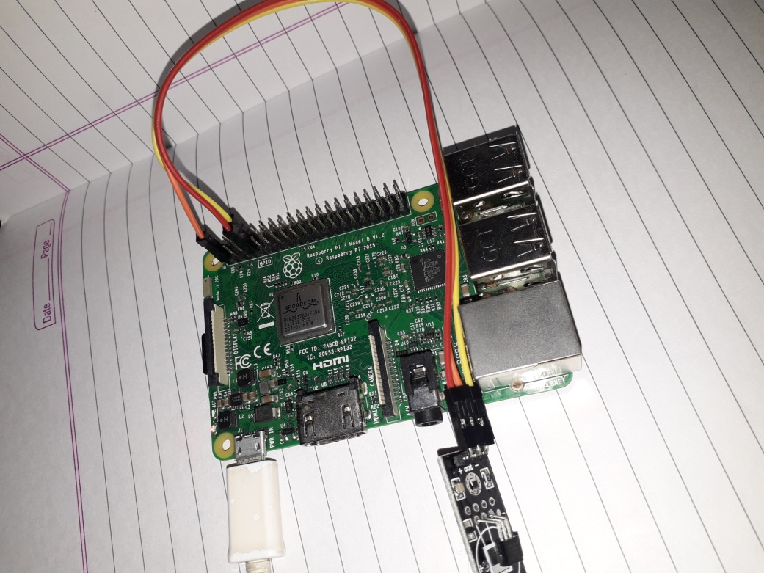

1. Positive of LED to GPIO Pin of Pi
2. Negative of LED to GND pin of Pi

* Working:

Note: For this System. The Programming is done in Node Red and Thingspeak is used in Cloud Service.

The timestamp is set to trigger the Pi-ds18b20 Sensor mode every 30 minute that will import the Temperature data from Pi and then the Function and http request will upload the

Temperature on the Thingspeak service “Update Channel Feed”.

Then the person may request the last temperature update via the “Get Channel feed” link.

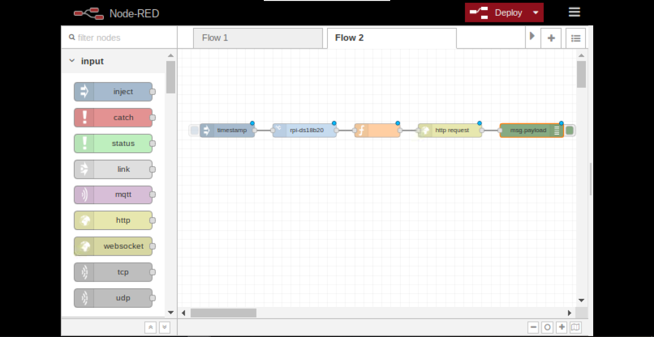

Here the time stamp is set to request the temperature update from Thingspeak every 30 minutes. The Output is in String from and is converted to a numerical value by Json node.

Then the function nodes checks when then the temperature is greater than the set Critical Temperature. If yes it gives one as output and the switch nodes checks it. If the output is 1 then an email is sent to the set email asking if the person wants to turn over the Air Conditioner [in the trial case LED].

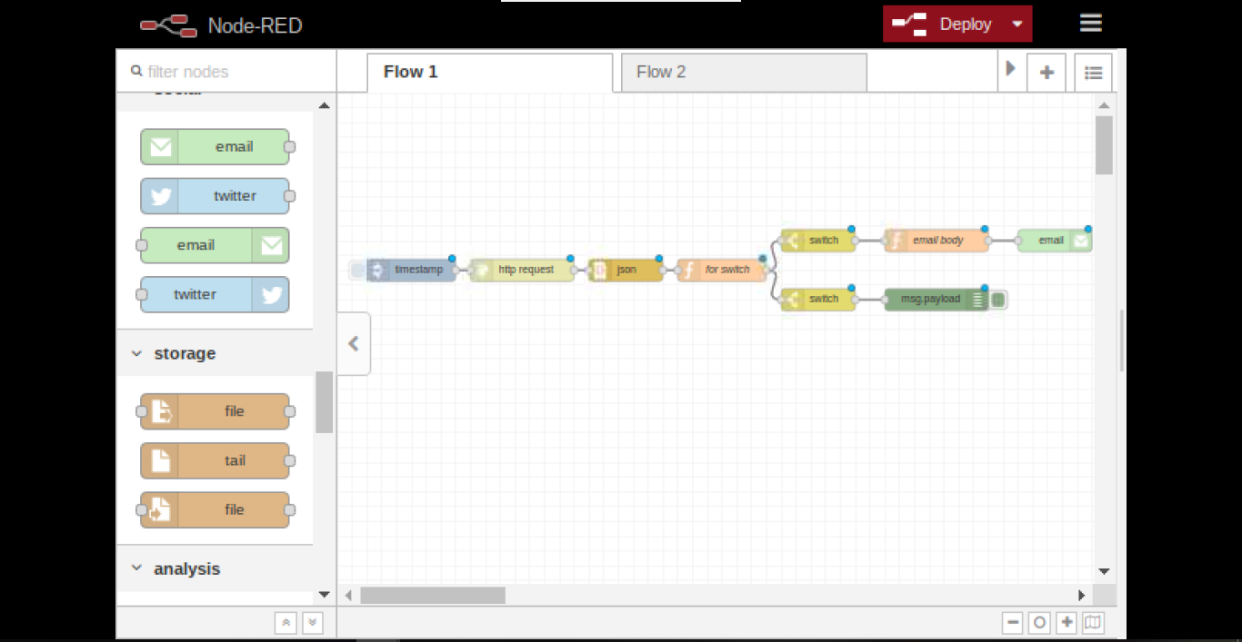

The email node checks for a mail every 10 minutes if a mail is received it is processed & if it contains “yes” from the Owner then the Output is given to GPIO Pin and the LED is turned on.

